- JavaScript fundamentals and advanced internals

- var, let, const, scope, hoisting, Temporal Dead Zone

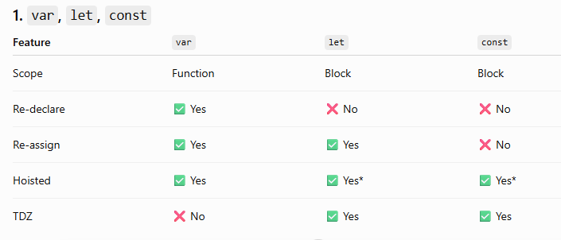

var → function scope + hoisted with undefined
Let → block scope + TDZ
const → block scope + TDZ + cannot reassign

Temporal Dead Zone --The Temporal Dead Zone is the period between entering a scope and the point where a let or const variable is initialized.

var:
var a;
console.log(a); // undefined
a = 10;

let:
// b exists in the scope but is in TDZ
console.log(b); // ReferenceError
let b = 20;

- Closures, lexical scope, practical closure use cases

Lexical scope means a function can access variables based on where the function was written in the code.

CLosure-
A closure is a function bundled with references to the variables from its surrounding lexical scope

Where are Closures Used in Real Applications?

You will commonly encounter closures in:

- Callbacks
- setTimeout / setInterval
- Event handlers
- Promises / async operations
- Private state
- Memoization/caching
- Function factories
- Debouncing and throttling
- JavaScript modules
- React hooks and Angular callbacks

If the interviewer asks:

"What is a closure and where have you used it?"

A strong answer would be:

"A closure is when a function retains access to variables from its lexical scope even after the outer function has finished execution. I've used closures in callbacks, event handlers, debouncing, maintaining private state, and memoization. For example, a debounce function uses a closure to retain the timer ID between function calls."

- this, call(), apply(), bind()

- These all sets context of “this” in a same object to another object called by these methods.
- call(), apply(), and bind() are used to control the value of this.
- call() and apply() invoke the function immediately, while bind() returns a new function with this permanently bound. The main difference between call() and apply() is that call() accepts arguments individually, whereas apply() accepts them as an array.

Example-
const employee = {
name: "John"
};
function printEmployee(department, role) {
console.log( this.name, department, role );
}

With call - printEmployee.call(employee, "IT", "Developer");
With apply - printEmployee.apply(employee, ["IT", "Developer"]);
With bind -
const print = printEmployee.bind(employee);
print("IT", "Developer");

- Arrow functions vs regular functions

- Regular functions have their own this; arrow functions inherit this from their lexical scope.
- Regular functions have an arguments object.
- Arrow functions don't have their own arguments.
- arrow functions cannot be called with new keyword.

What is the difference between arrow and regular functions?, you can answer:
"The main difference is how they handle this. Regular functions have their own this, which is determined by how the function is invoked. Arrow functions don't have their own this; they inherit it from the surrounding lexical scope. Arrow functions also don't have their own arguments, cannot be used as constructors with new, and their this cannot be changed using call, apply, or bind. I generally use arrow functions for callbacks and regular functions or method syntax when I need a dynamically bound this."

- Primitive vs reference types

- Shallow copy vs deep copy, structured cloning

//Shallow copy
//use spread operator to create a shallow copy of an object
const obj1 = { a: 1, b: 2 };
const shallowCopy = { ...obj1 };

console.log(shallowCopy); // Output: { a: 1, b: 2 }

shallowCopy.a = 3;
console.log(obj1.a); // Output: 1 (original object remains unchanged)
console.log(shallowCopy.a); // Output: 3 (shallow copy is modified)

//Deep copy (used when nested objects are there)
//use JSON.parse and JSON.stringify to create a deep copy of an object
const obj2 = { a: 1, b: { c: 2 } };
const deepCopy = JSON.parse(JSON.stringify(obj2));

console.log(deepCopy); // Output: { a: 1, b: { c: 2 } }

deepCopy.b.c = 3;

console.log(obj2.b.c); // Output: 2 (original object remains unchanged)
console.log(deepCopy.b.c); // Output: 3 (deep copy is modified)
For Deep copy you can also use structuredClone;
eg.
const user2 = structuredClone(user1);
What is the difference between primitive and reference types?", say:

"Primitive types hold immutable values such as strings, numbers, booleans, null, undefined, bigint, and symbols. When we assign or pass a primitive, its value is copied, so the variables are independent.
Objects, arrays, and functions are reference values. When we assign them to another variable, both variables refer to the same object, so modifying the object through one reference can affect the other. We can use techniques like the spread operator for shallow copies and structuredClone() when a deep copy is required."

- Destructuring, spread/rest, optional chaining, nullish coalescing
- Prototype chain, prototypal inheritance, classes
- Property descriptors, getters/setters, Object.freeze() and seal()
- Map, Set, WeakMap, WeakSet
- Iterators, generators, symbols
- Promises and all, allSettled, race, any
- async/await, error propagation, unhandled rejections
- Event loop, microtasks, macrotasks, execution context
- Memory management and garbage collection
- ES modules vs CommonJS, module caching
- TypeScript basics, generics, utility types, type narrowing

